# Running & Testing the Network

*EPC ip: 192.168.122.36/24*

*eNodeB: 192.168.122.6/24*

1. To check the status of MME service (from EPC):

sudo systemctl status open5gs-mmed.service

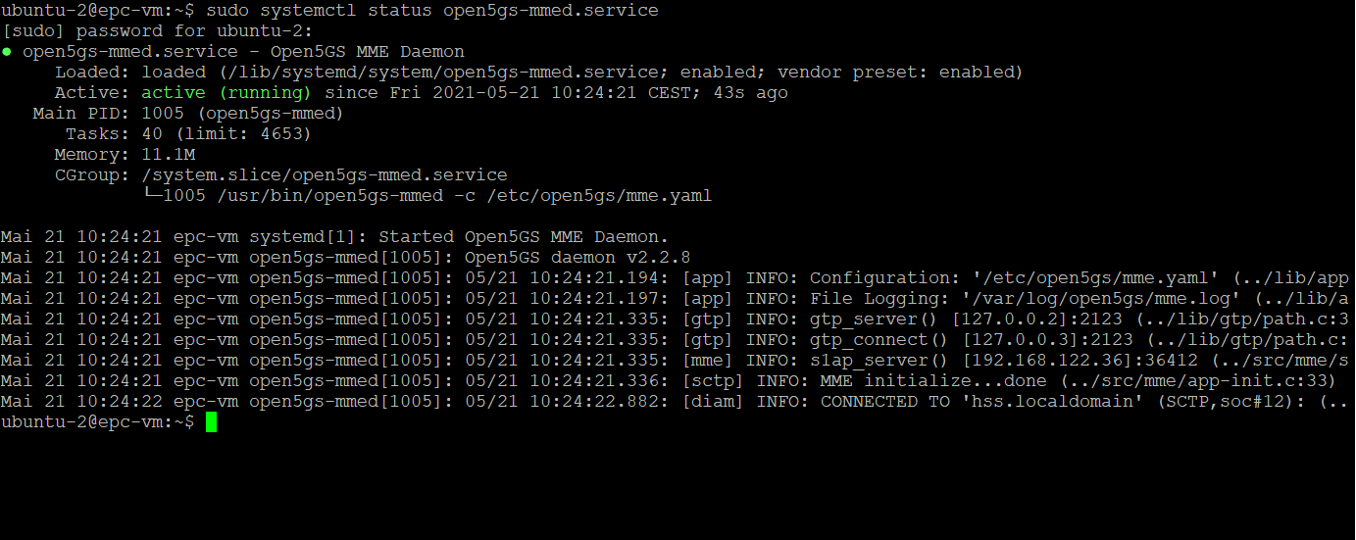

1. Watch the live MME log (from EPC)

Sudo tail -f /var/log/open5gs/mme.log

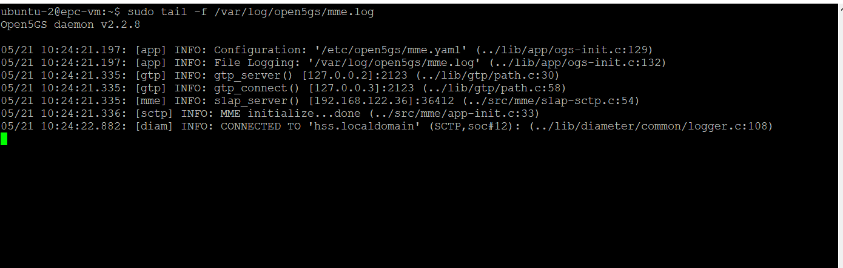

1. Running eNodeB:

cd srsRAN/build

./srsenb/src/srsenb --rf.device_name=zmq --rf.device_args="fail_on_disconnect=true,tx_port=tcp://*:2000,rx_port=tcp://localhost:2001,id=enb,base_srate=23.04e6"

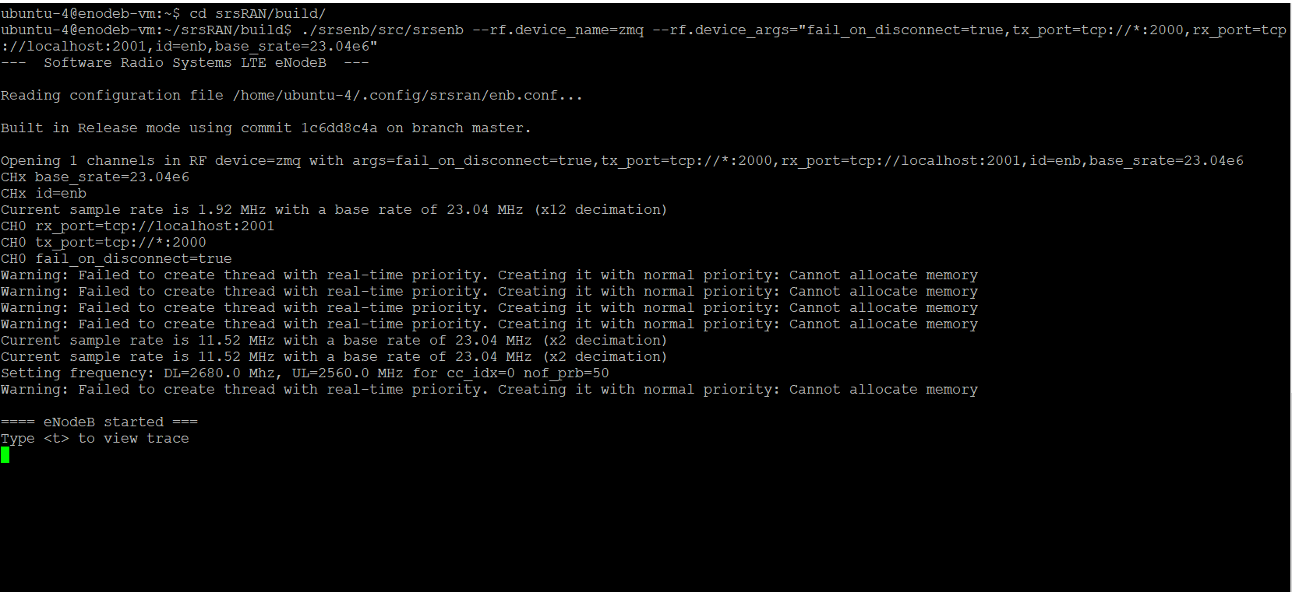

From mme log file, it can be seen that eNB is now 1.

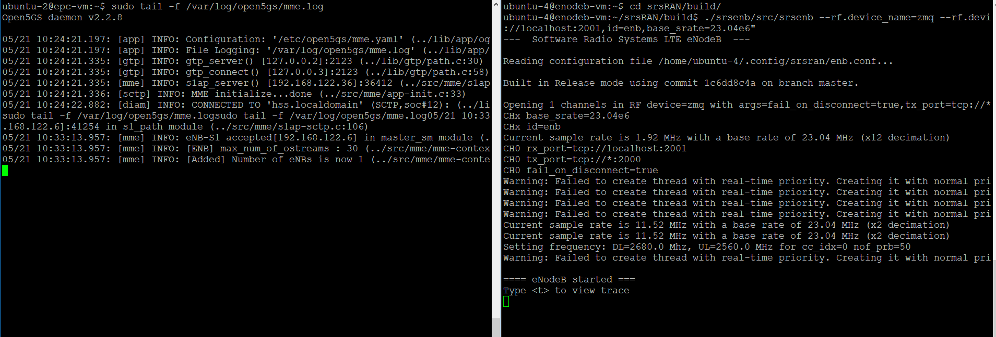

1. Running UE:

cd srsRAN/build

sudo ./srsue/src/srsue --rf.device_name=zmq --rf.device_args="tx_port=tcp://*:2001,rx_port=tcp://localhost:2000,id=ue,base_srate=23.04e6" --gw.netns=ue1

All three function are running (MME , eNodB, UE)

1. Ping and Iperf: To trace the traffic type t in eNodB and UE.

** To generate load via Iperf:

make iperf server in EPC and generate load from enodeB.

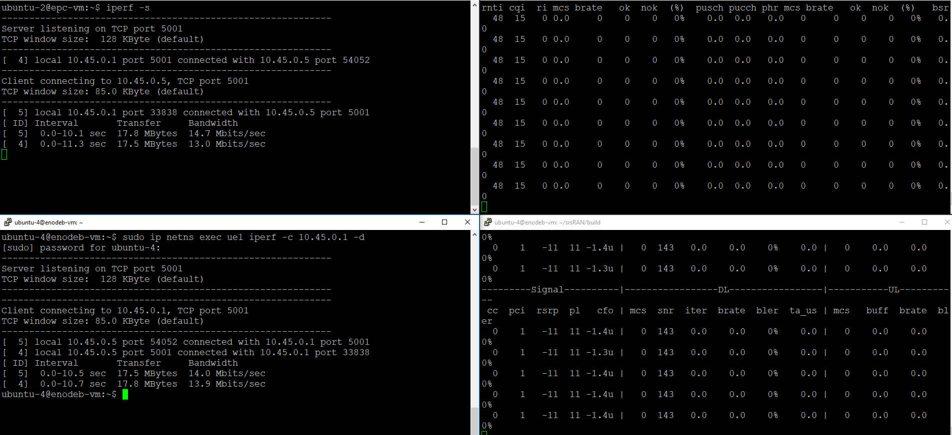

Make iperf server in endoB and generate traffic from EPC.

Useful tips:

Restart mme: sudo systemctl restart open5gs-mmed

Check Ip tables, NAT rules.

Extra attention to ue.conf,enb.conf,epc.conf file.

Locate appropriate file, then make changes. Its better to have a backup file to compare changes between two file. (using diff command)